SQL Task

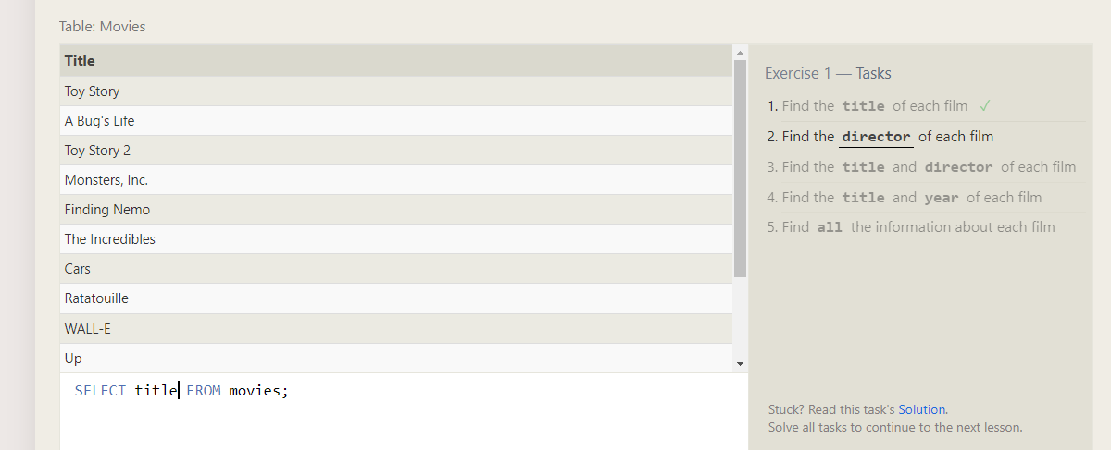

Director

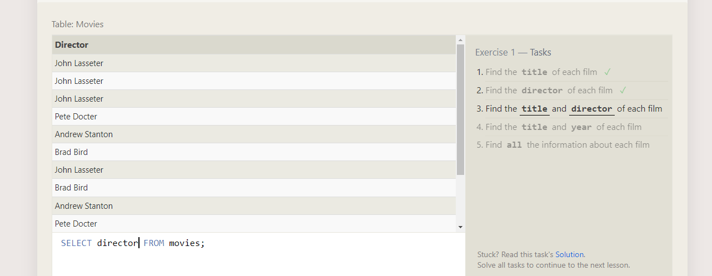

Title and Director

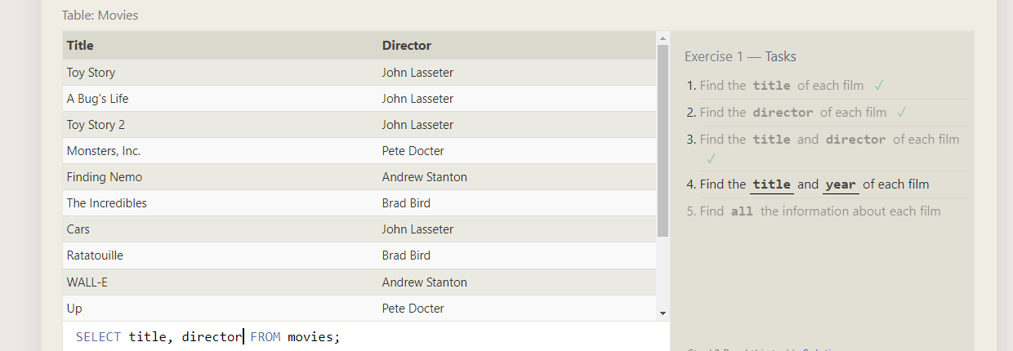

Title and year

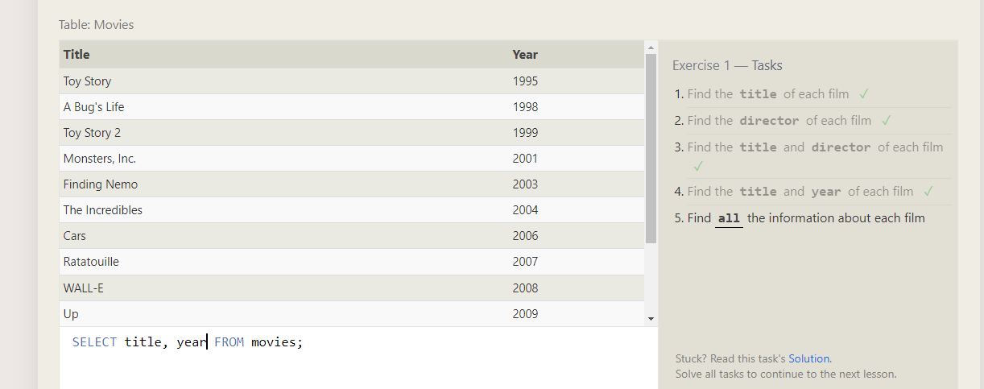

All

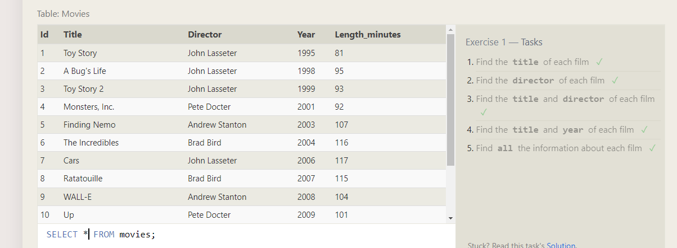

**SQL Lesson 2: Queries with constraints (Pt. 1)**

Row id 6

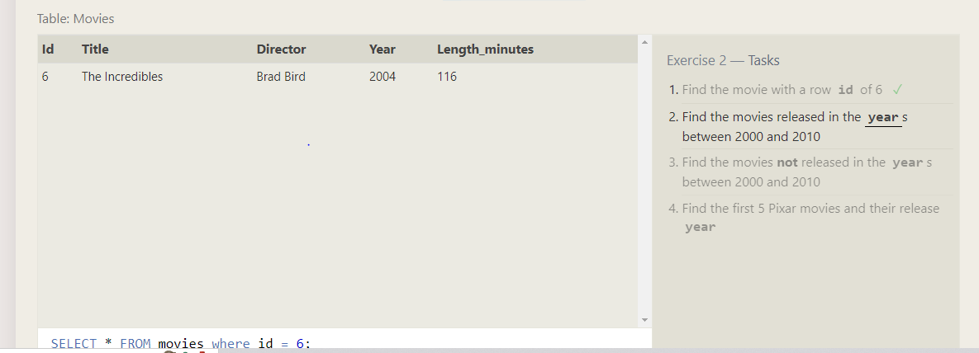

Between 2000 and 2010

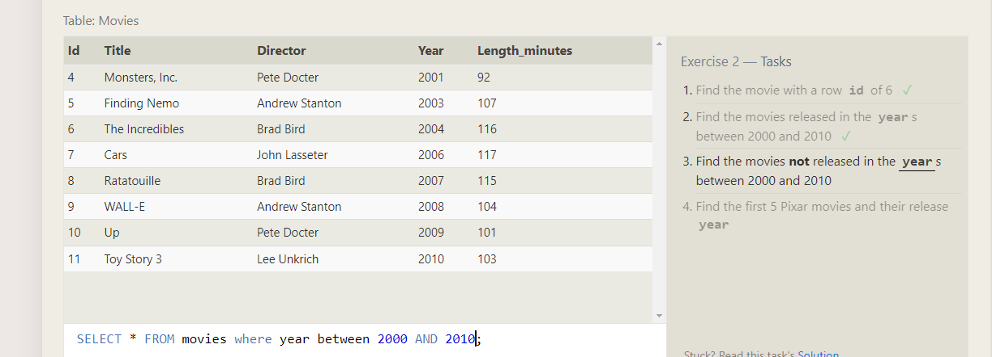

Not between 2000 and 2010

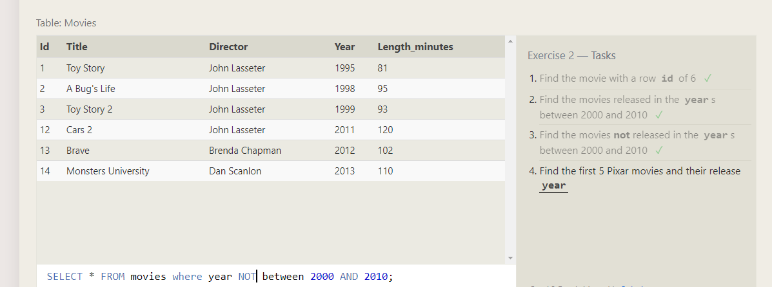

5 pixar movies and release year

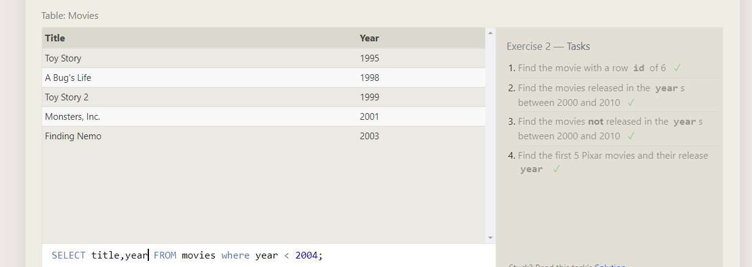

**SQL Lesson 3: Queries with constraints (Pt. 2)**

All toy story

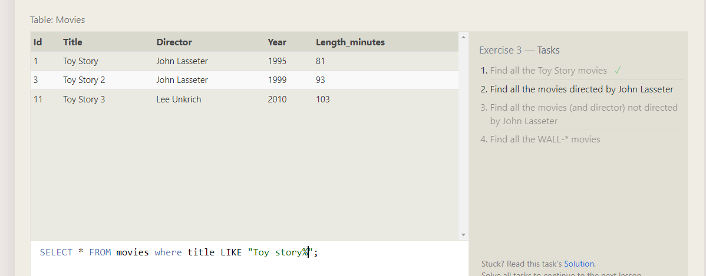

Director movies

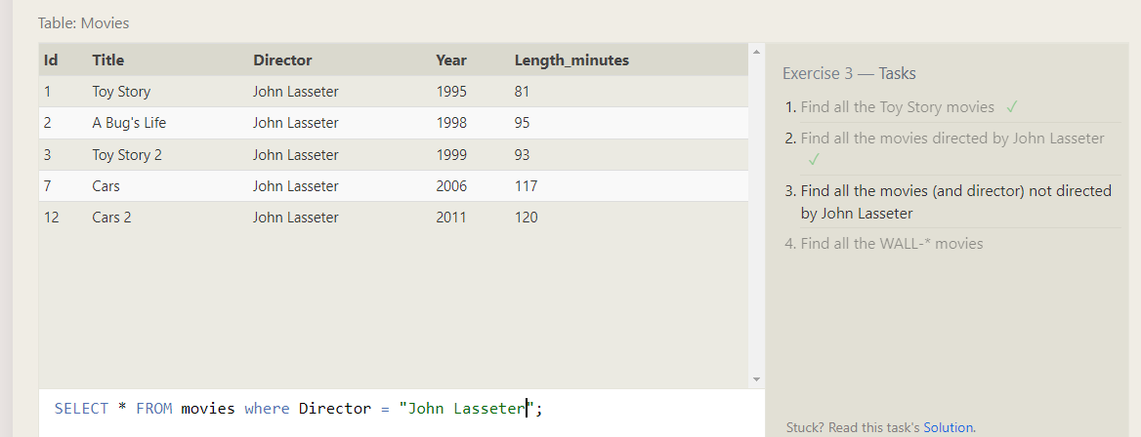

Not directed movies by director

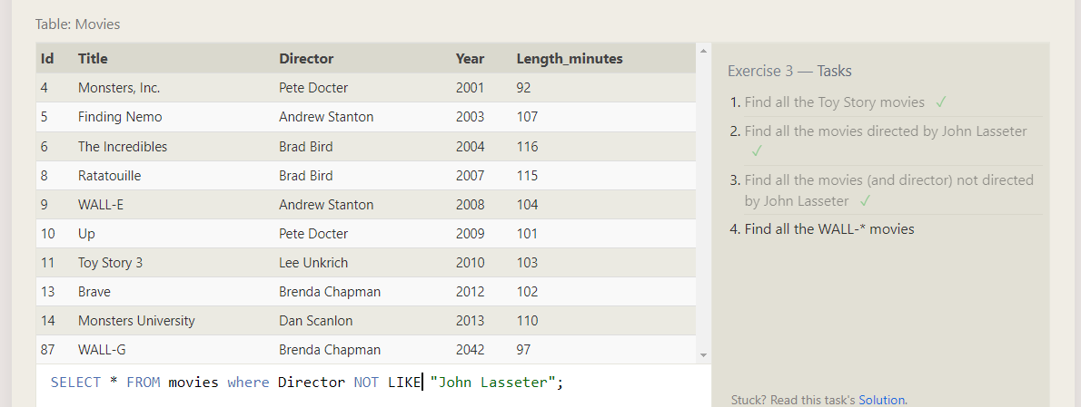

All Wall- movies

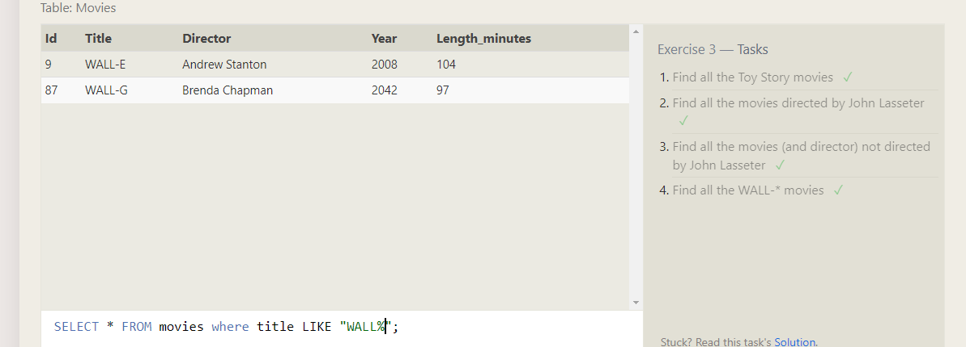

**SQL Lesson 4: Filtering and sorting Query results**

All directors alphabetically

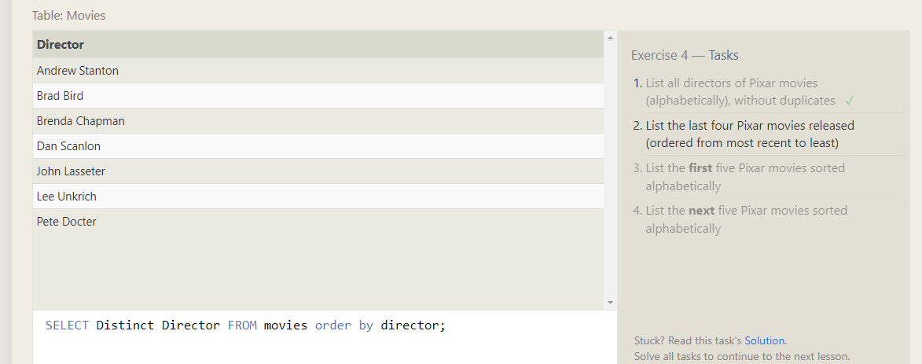

Title an year from most recent to least

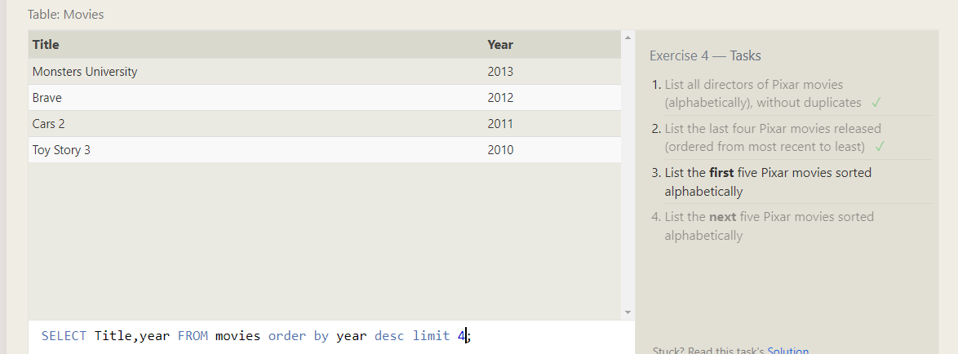

5 sorted title alphabetically

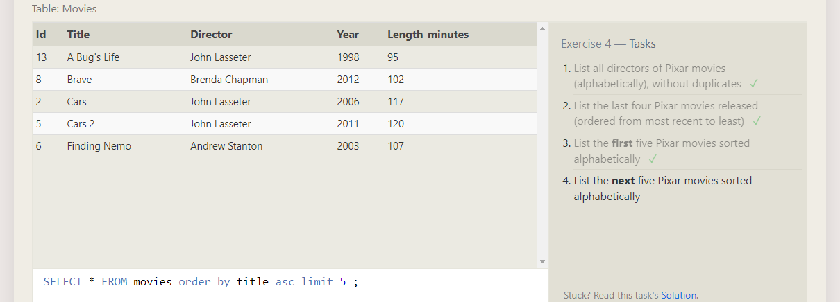

Next 5 title 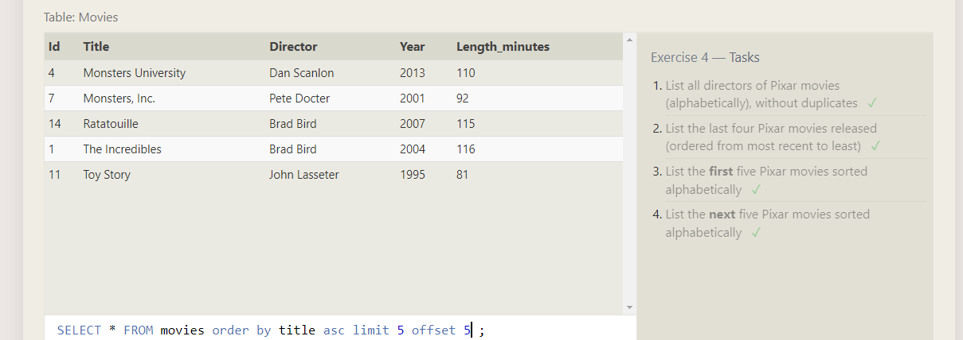

**SQL Review: Simple SELECT Queries**

Canadian city and population

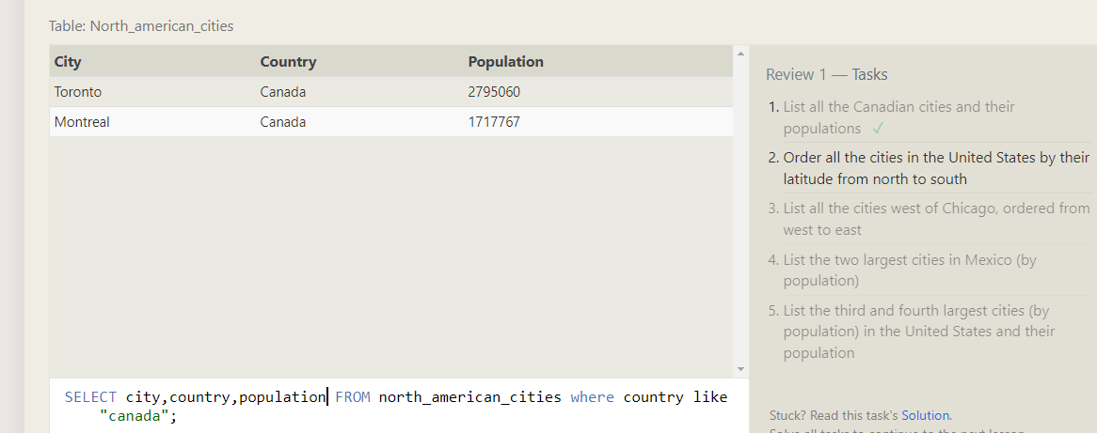

United states cities and latitude ,latitude set by north to south

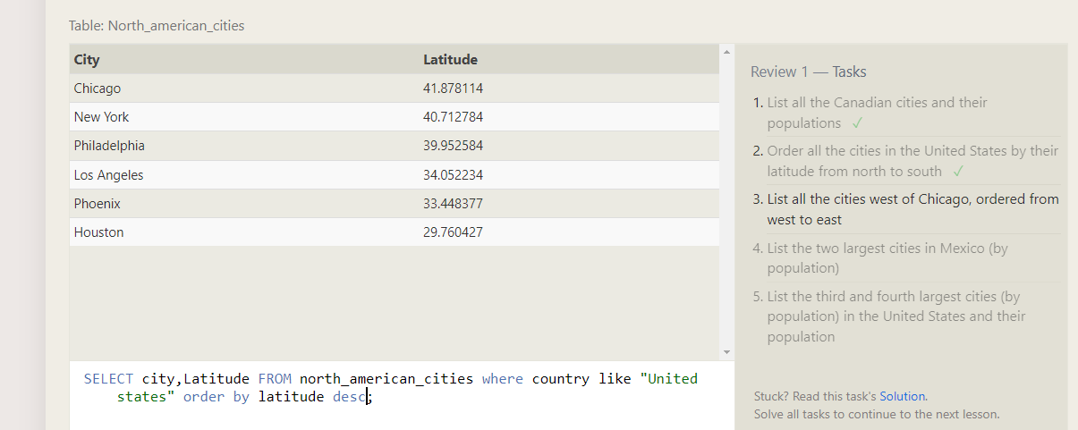

Chicago cities from west to east of longitude

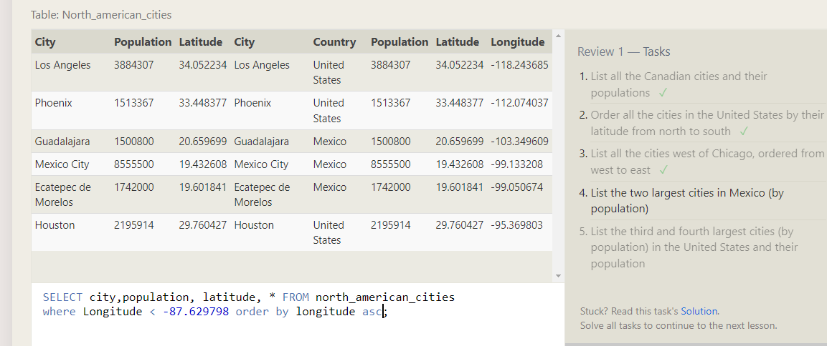

Two largest cities in mexico by population

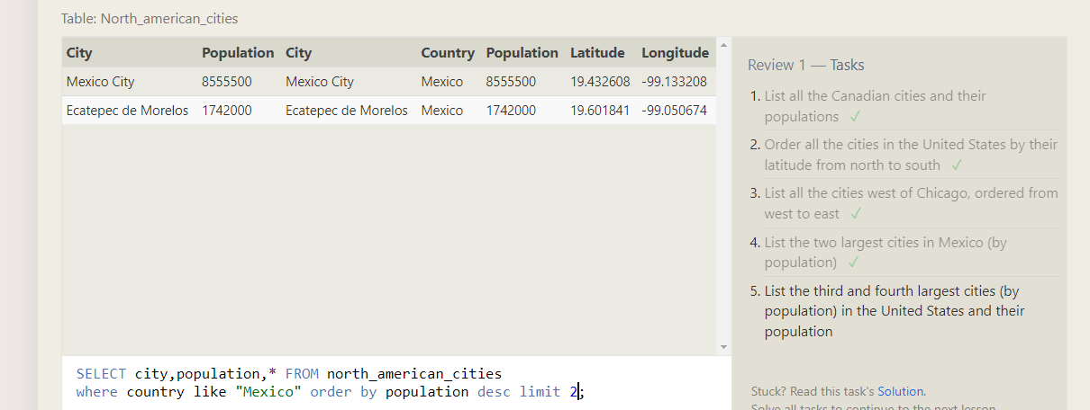

List of third and fourth population in united states

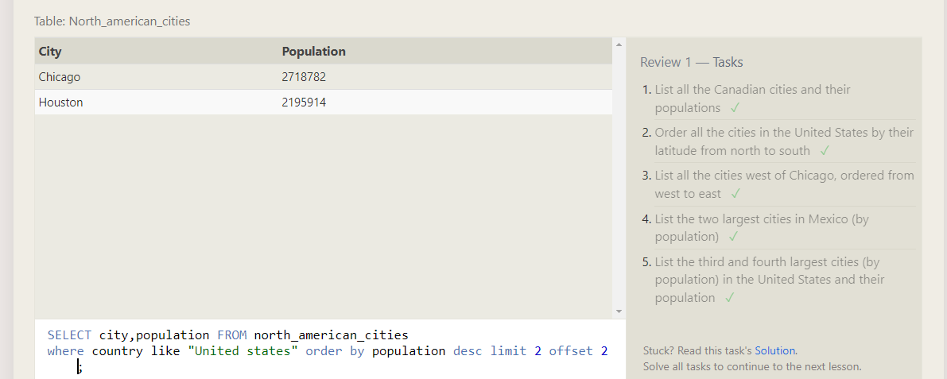

**SQL Lesson 6: Multi-table queries with JOINs**

Inner link of domestic and international sale of the movie

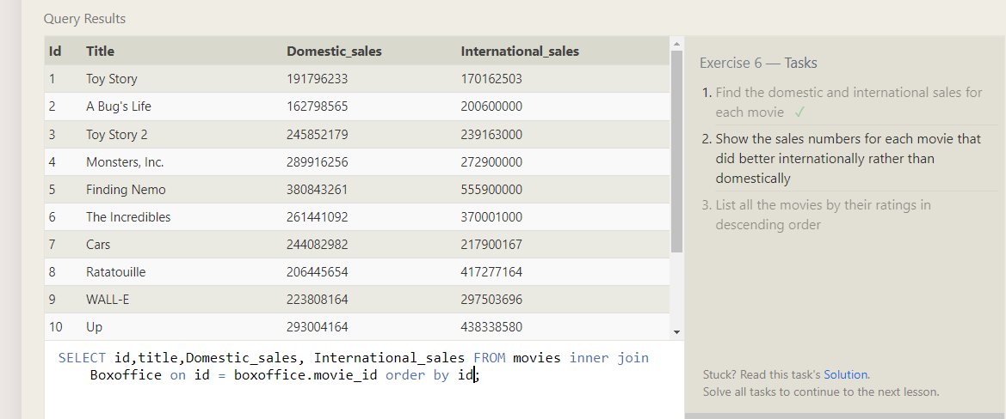

Movie did better than Domestic_sales to International_sales

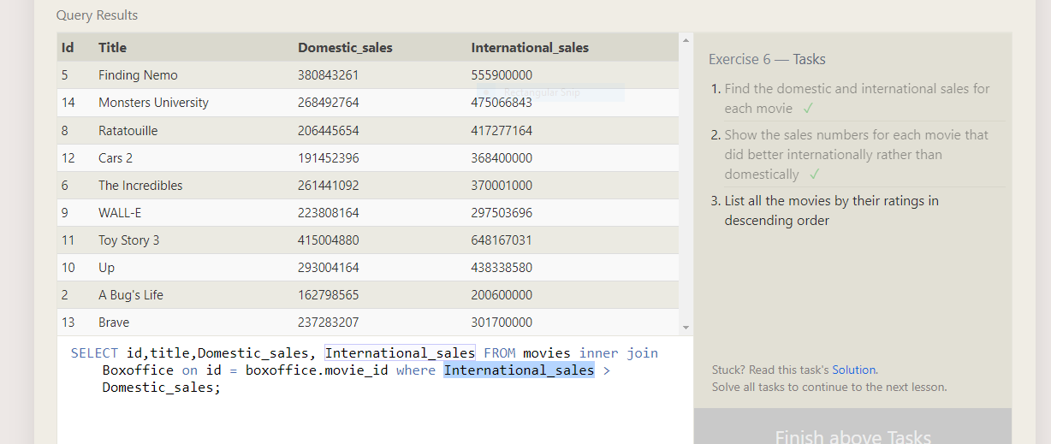 Rating order by descending

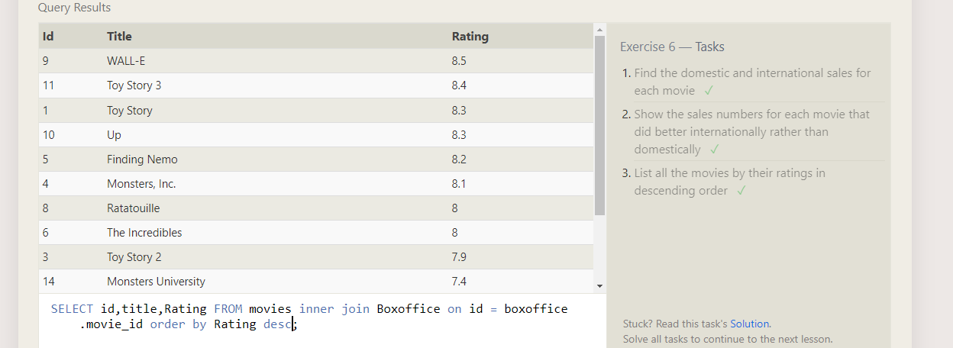

**SQL Lesson 7: OUTER JOINs**

All buildings that have employess

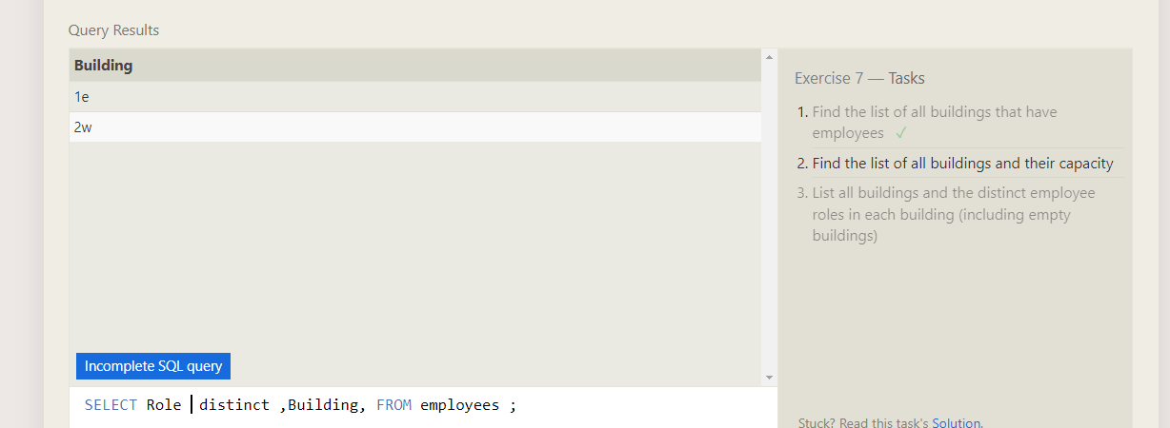

All buildings and capacity

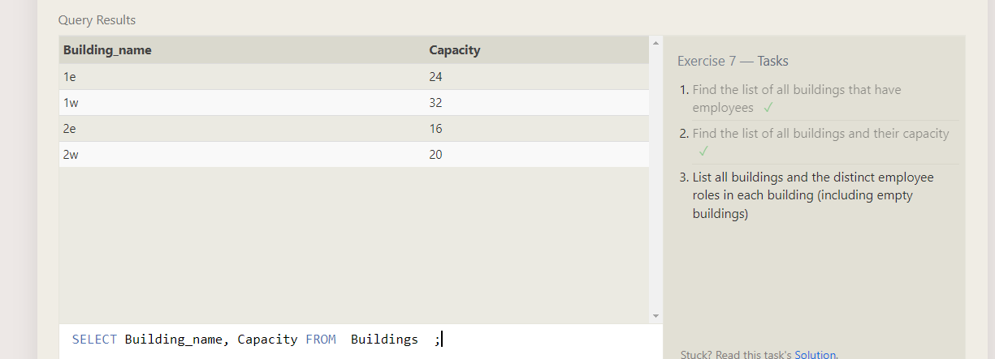

All building and distinct employess

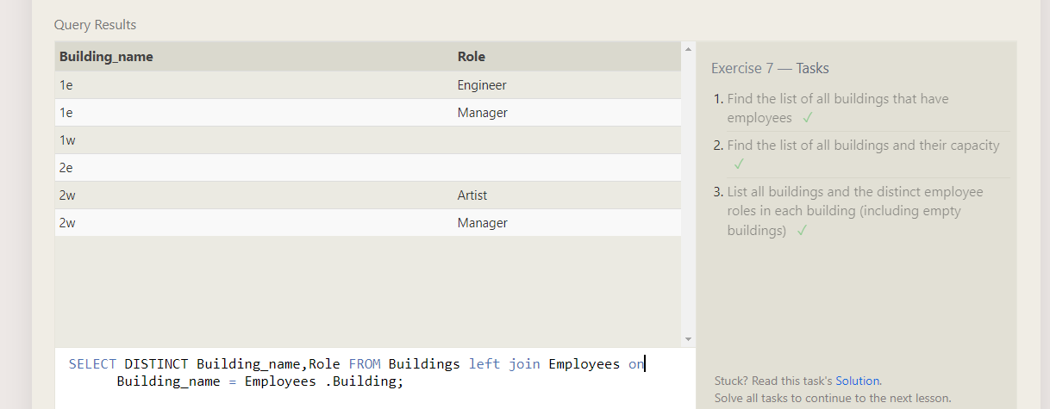

**SQL Lesson 8: A short note on NULLs**

Building not assigned to employee

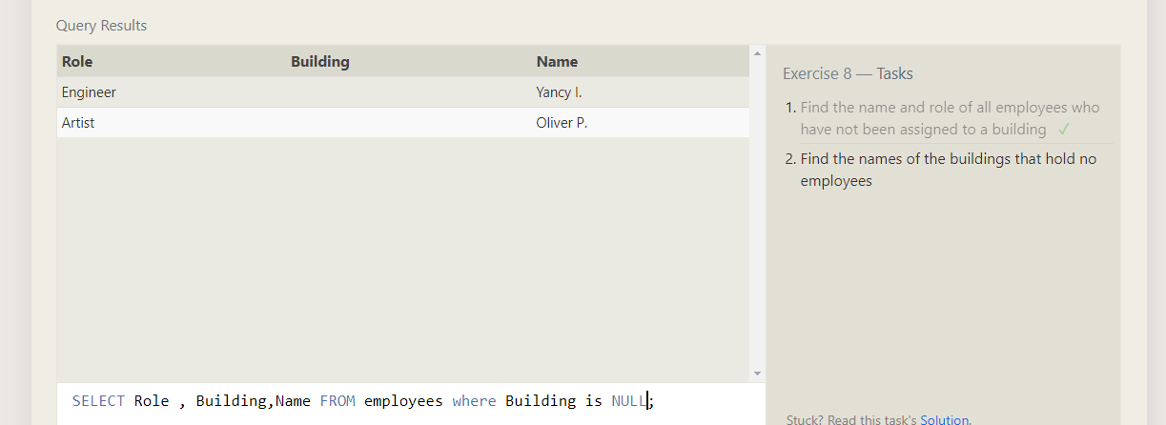

Building that holds no role

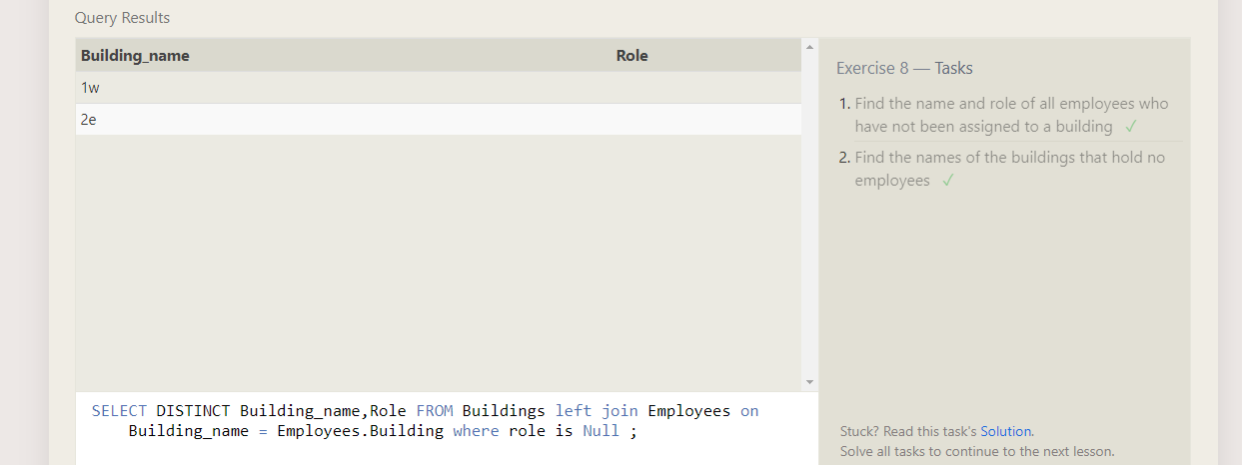

**SQL Lesson 9: Queries with expressions**

All movie sale in millions

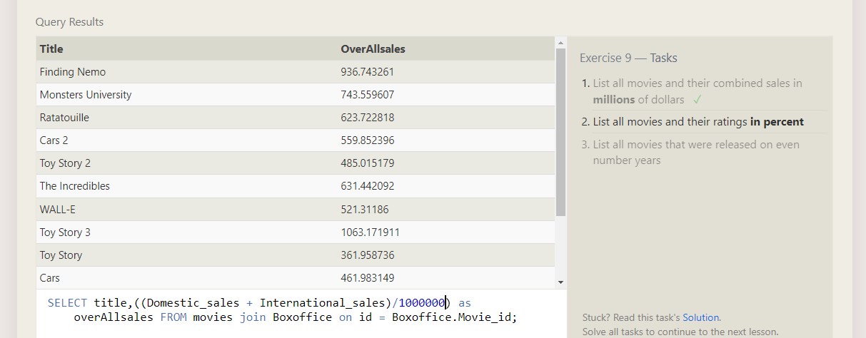

Rating in percentage

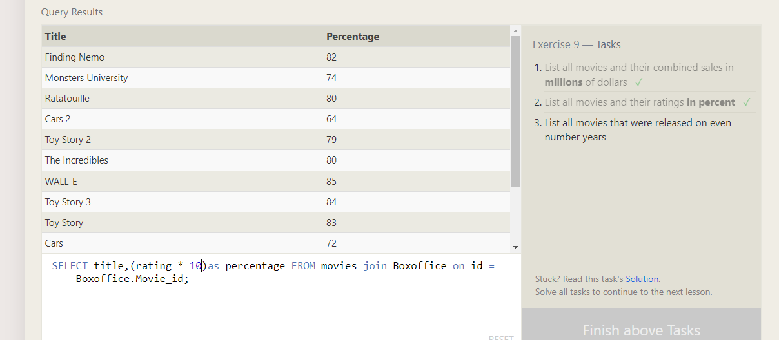

Movies released on even numbers

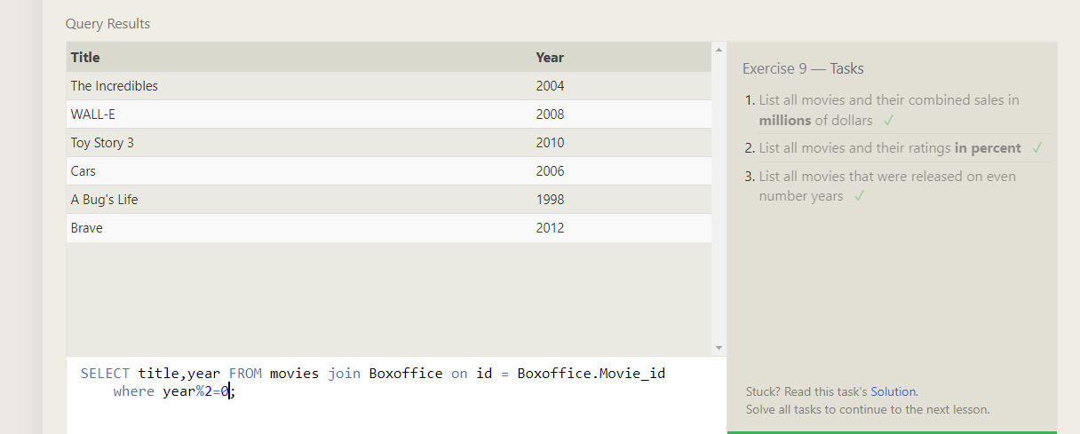

**SQL Lesson 10: Queries with aggregates (Pt. 1)**

Longest Employee

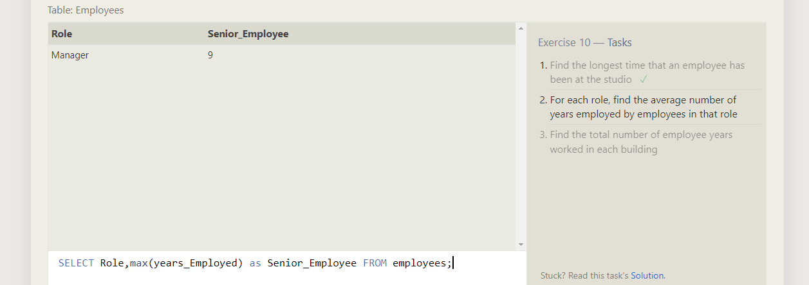

Average number of years by employed by employees

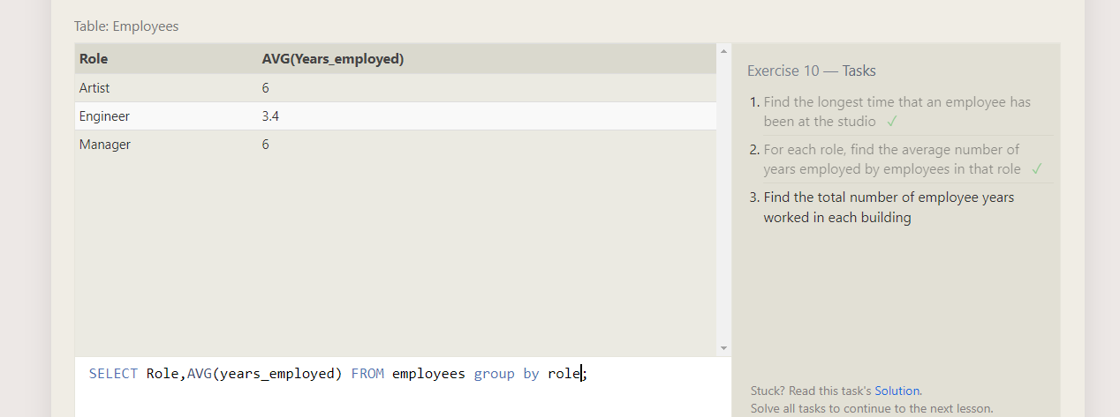

Number of years employed in each building

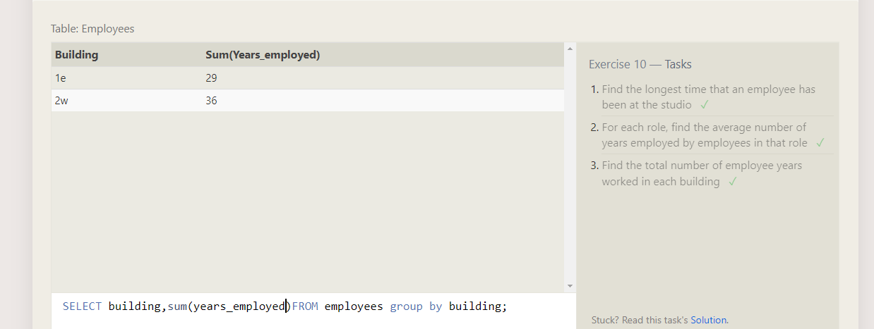

**SQL Lesson 11: Queries with aggregates (Pt. 2)**

Number artist in studio

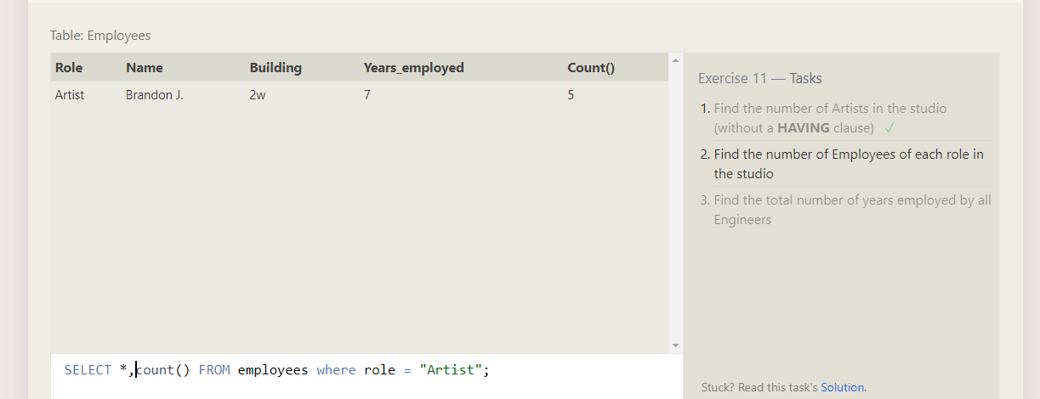

Number of employees in each role

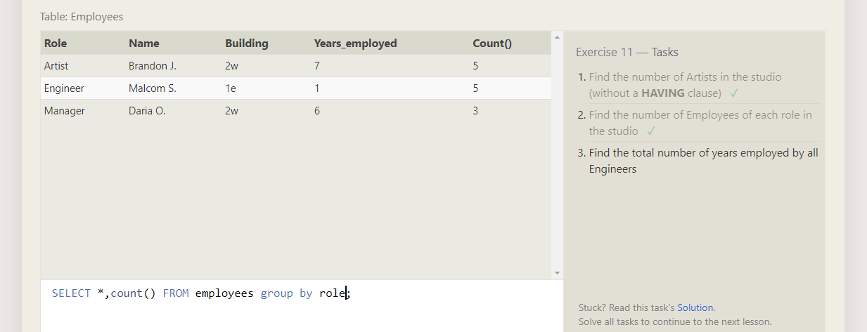

Total number years employed by all engineers

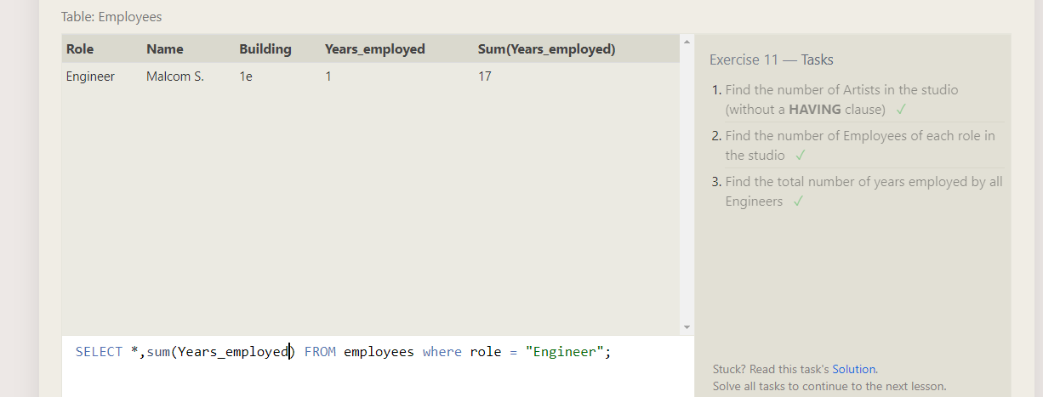

**SQL Lesson 12: Order of execution of a Query**

Number of movies directed by each director

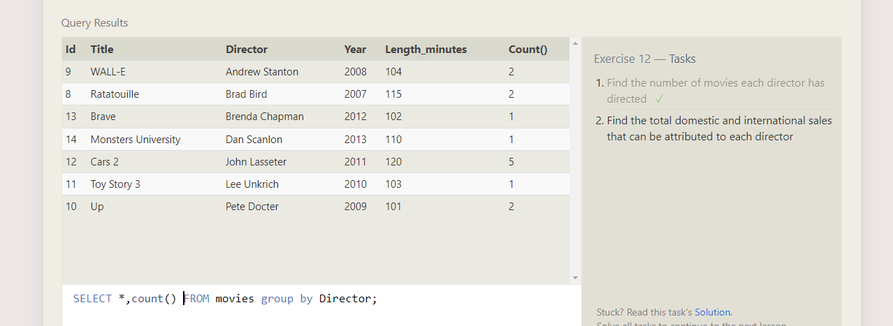

Total of international and Domestic sales

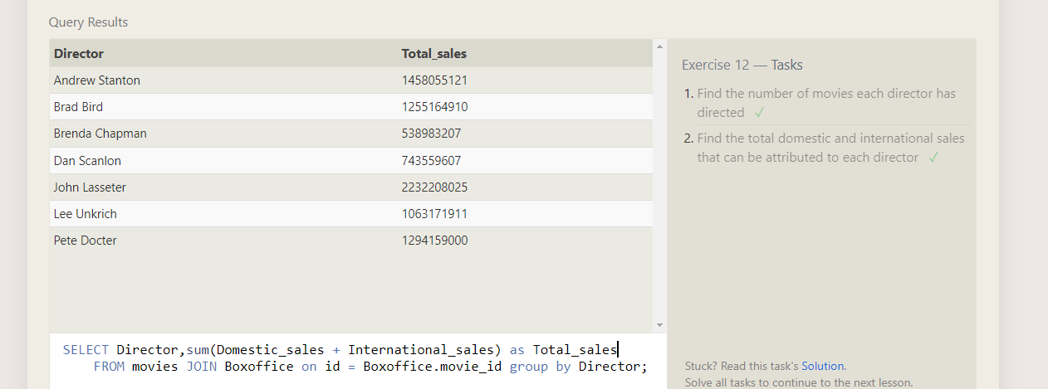

**SQL Lesson 13: Inserting rows**

Add new movie to the movies list

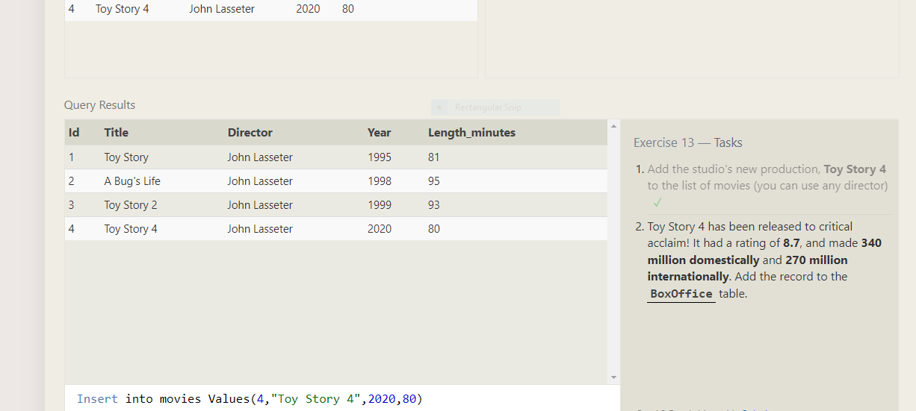

Add new movie in boxoffice collection

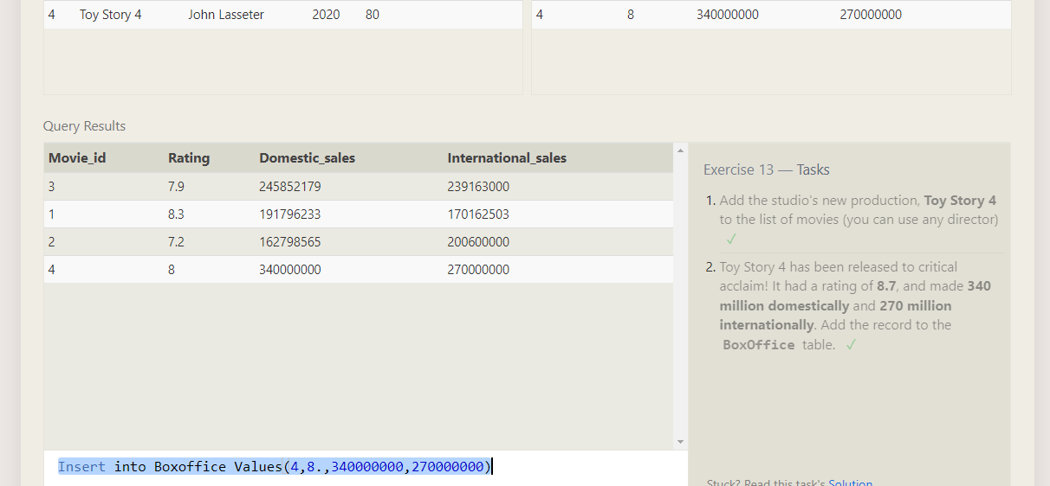

**SQL Lesson 14: Updating rows**

Updating director name

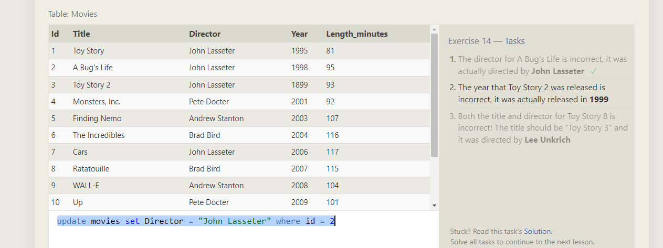

Updating year of the movie

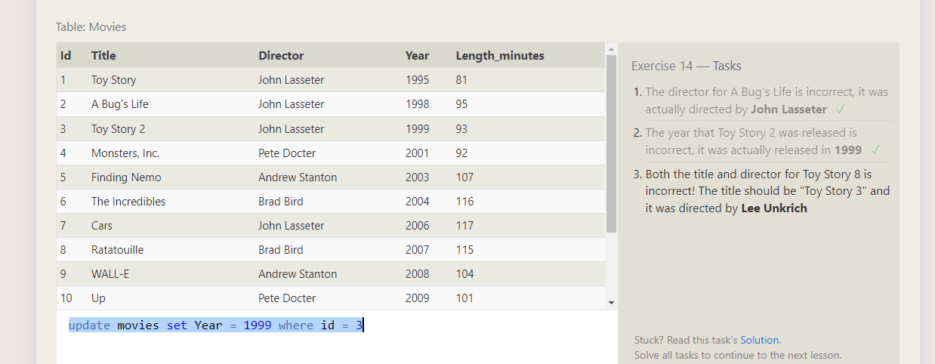

Updating two columns

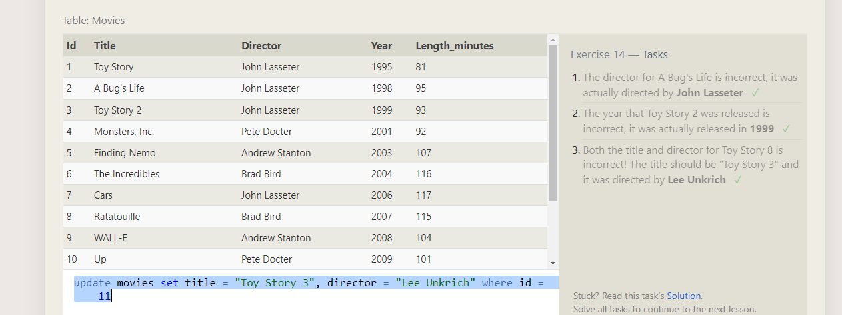

**SQL Lesson 15: Deleting rows**

Deleting movies released before 2005

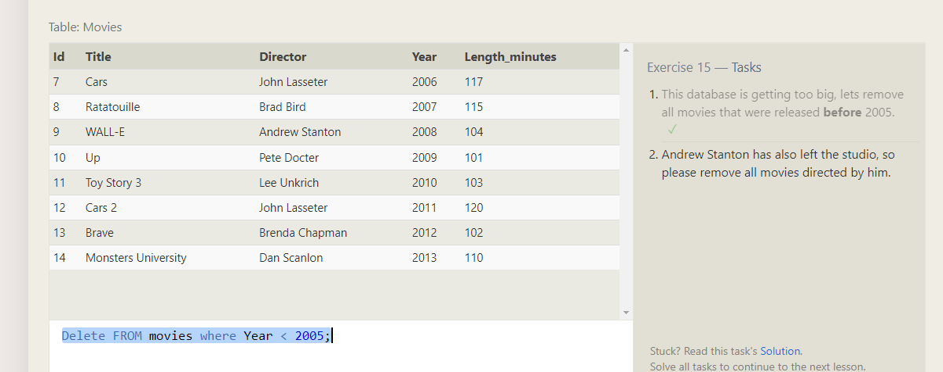 Deleting director

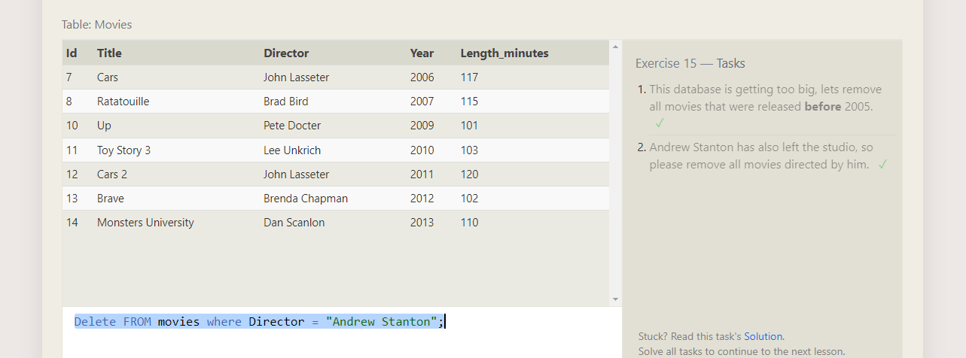

**SQL Lesson 16: Creating tables**

Creating a table Database

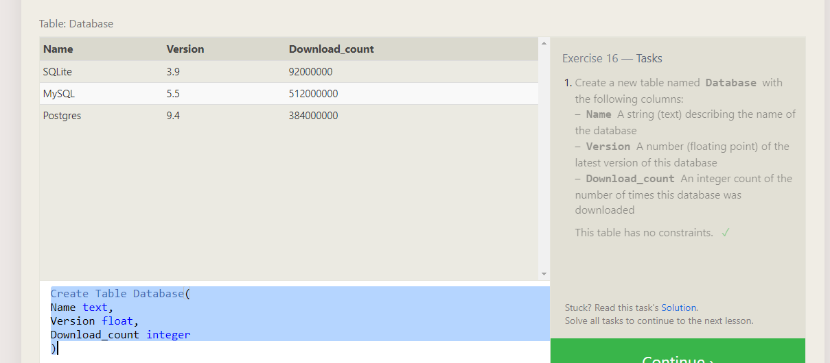

**SQL Lesson 17: Altering tables**

Alternating a table adding aspect_ratio column with value 9.2

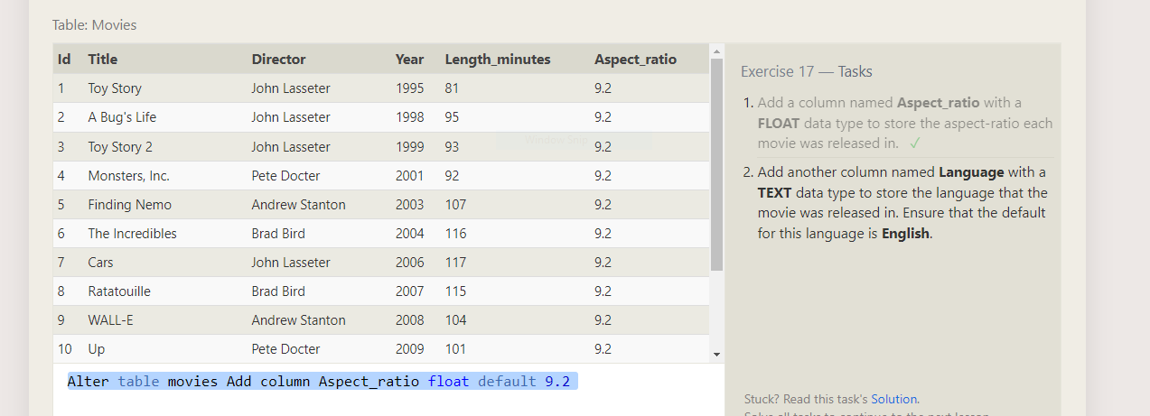

Language column text as English

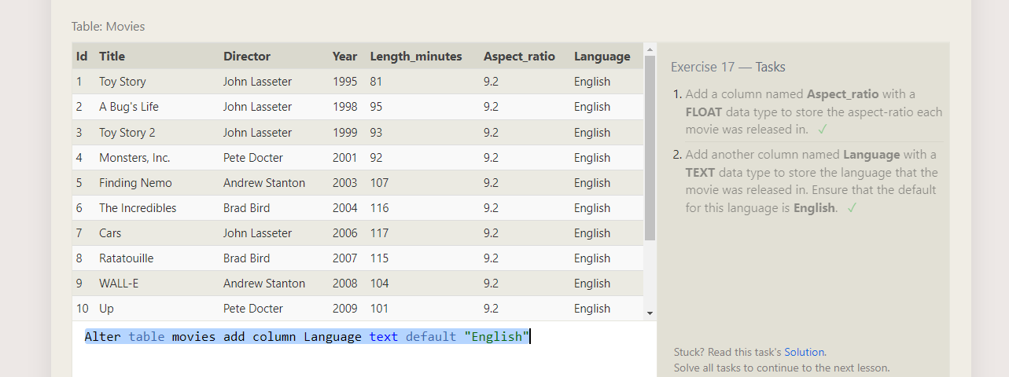

**SQL Lesson 18: Dropping tables**

Dropping movies

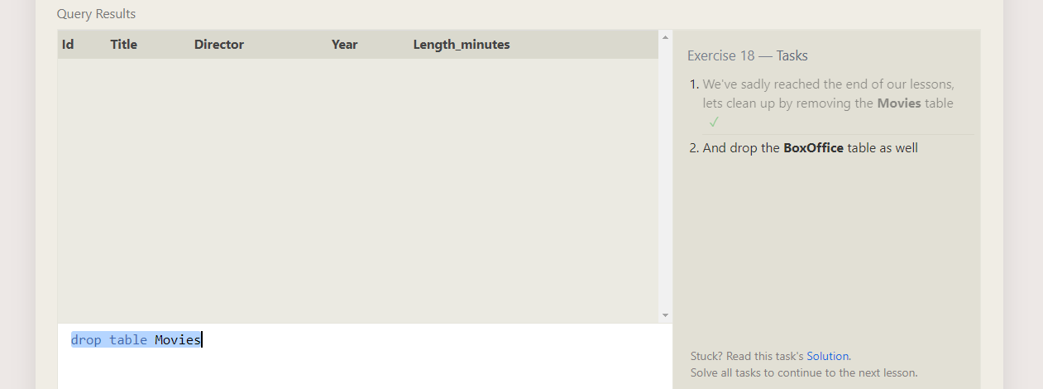

Dropping Boxoffice

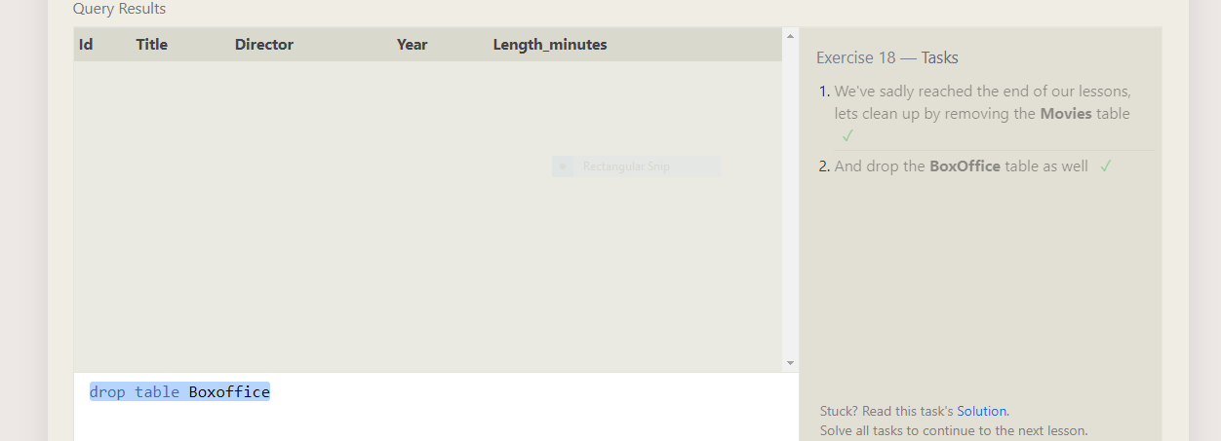

Completion Certificate

